|  |
| --- |
| Maui nui marine resource council |
| Options to Improve Wastewater Management in South Maui |
|  |
|  |
| **Prepared by: Steve Parabicoli** |
| **7/20/2016** |

|  |
| --- |
|  |

Table of Contents

List of Figures 1

List of Definitions and Abbreviations 2

Executive Summary 4

1. Introduction 5

2. Wastewater Systems and Options for Improvement 5

2.1 The County of Maui’s Kihei Wastewater Reclamation Facility 5

2.11 Options to Reduce the Impact of the Kihei WWRF Injection Wells on the Environment and Public Health 8

2.2 Maalaea 12

2.21 Options to Improve Wastewater Management in the Maalaea Area 13

2.3 Maui Meadows 15

2.31 Options to Improve Wastewater Management in Maui Meadows 17

2.4 Makena 19

2.41 Options to Improve Wastewater Management in Makena 19

3. Summary of Recommendations 22

4. References 23

# List of Figures

Figure 1: Kihei WWRF Service Area 6

Figure 2: Kihei WWRF Process Flow Diagram 7

Figure 3: Kihei WWRF Flexible Aeration Basin 8

Figure 4: The Bardenpho Process with Supplemental Carbon Addition 10

Figure 5: The Maalaea Area’s Existing Commercial and Multi-Family Developments 13

Figure 6: Maui Meadows Subdivision 15

Figure 7: Cesspool 16

Figure 8: Septic Tank 16

Figure 9: Septic System 16

Figure 10: Aerated Treatment Unit 17

Figure 11: Makena 20

# List of Definitions and Abbreviations

* Aerobic: In the presence of oxygen. The activated sludge aerobic zones have a dissolved oxygen concentration of 2 -3 milligrams per liter. Aerobic conditions are necessary for secondary treatment (biological oxidation) of wastewater to occur.
* Anaerobic: The opposite of aerobic as in without oxygen.
* Anoxic: Waters that have a dissolved oxygen concentration of less than 0.5 milligrams per liter.
* ATU: Aerobic Treatment Unit. A small wastewater treatment system used to treat wastewater from a single family home.
* Bardenpho Process: A process utilized at wastewater treatment plants to biologically reduce nitrogen and phosphorous.
* Biological Treatment: Methods of wastewater treatment where bacterial or biochemical action is used as a means of producing oxidized wastewater.
* BOD: Biochemical Oxygen Demand. BOD is the amount of dissolved oxygen needed by aerobic biological organisms to break down organic material present in a given water sample at certain temperature over a specific time period.
* BNR: Biological Nutrient Removal. Nitrate is reduced to nitrogen gas by denitrification in anoxic zones.
* CAB: Conventional Aeration Basin
* CAS: Conventional Activated Sludge.
* CBOD: Carbonaceous Biochemical Oxygen Demand. CBOD is a method defined test measured by the depletion of dissolved oxygen by biological organisms in a body of water in which the contribution from nitrogenous bacteria has been suppressed.
* Disinfection: A process which inactivates or removes pathogenic organisms in water by chemical or physical means.
* Denitrification: Where nitrate is broken down by heterotrophic bacteria under anoxic or anaerobic conditions resulting in the formation of nitrogen gas.
* DWS: The County of Maui’s Department of Water Supply.
* ENR: Enhanced Nutrient Removal. Supplemental carbon is added to anoxic zones or deep bed effluent filters to prolong denitrification for the purpose of removing additional nitrogen from wastewater effluent.
* EPA: Environmental Protection Agency
* Effluent: The liquid end product of the wastewater treatment process.
* Flexible Aeration Basin: A basin that can be configured in a variety of ways to create anoxic conditions for the purpose of removing nitrogen from wastewater through denitrification.
* GPD: Gallons per Day
* HAR: Hawaii Administrative Rules
* Heterotrophic Bacteria: Bacteria that convert nitrate to nitrogen gas.
* HDOH WWB: Hawaii Department of Health Wastewater Branch
* HDOH SDWB: Hawaii Department of Health Safe Drinking Water Branch
* Influent: Polluted domestic wastewater flowing into the wastewater treatment plant.
* Injection Well: A hole that is deeper than it is wide. An injection well is drilled deeper than the underlying water table and is used to dispose of treated wastewater. Injection wells are not allowed above a public source of drinking water such as a drinking water aquifer.
* IWS: Individual Wastewater System. An IWS is a decentralized system that receives and disposes domestic wastewater from one or multiple buildings that are not connected to a centralized wastewater treatment plant. Some IWSs treat wastewater by removing pollutants such as solids, organic matter, nutrients and bacteria. Not all systems provide equal levels of treatment. Suspended growth aerobic treatment systems provide secondary levels of treatment, for example, while others (such as septic tanks) only provide primary treatment of wastewater. Other IWSs only dispose of wastewater (e.g., cesspools).
* MGD: Million Gallons per Day
* MNMRC: Maui Nui Marine Resource Council
* Nitrification: The conversion of ammonia and ammonium to nitrite and nitrate by nitrifying bacteria. Aerobic conditions and adequate detention time must be present for full nitrification to take place.
* NH4: Ammonium
* NO2: Nitrite
* NO3: Nitrate
* Oxidized Wastewater: Wastewater that has undergone an aerobic treatment process in which the organic matter has been stabilized, is non putrescible, and contains dissolved oxygen.
* Pathogen: Any agent, especially a microorganism, capable of causing disease.
* Potable water: Water that is suitable for drinking by humans.
* RAS: Return Activated Sludge. RAS is activated sludge that is removed from secondary clarifiers and returned back to the front of the aeration basin.
* Reclamation or Treatment Facility: an arrangement of devices, structures, equipment, processes and controls which produce recycled water suitable for the intended reuse.
* Recycled water: Treated wastewater that by design is intended or used for a beneficial purpose. The HDOH WB has identified three classes of recycled water in its “Guidelines for the Treatment and Use of Recycled Water:
  + R-1 recycled water: The highest level of recycled water that has undergone secondary treatment, coagulation, filtration, and a high level of disinfection. It is considered virtually pathogen free water that can be used for irrigation of food crops and used for a variety of other purposes without restrictions.
  + R-2 recycled water: Recycled water that has undergone secondary treatment and that has been disinfected. Buffer zones are required when it is used via spray irrigation.
  + R-3 recycled water: Recycled water that has undergone secondary treatment but has not been disinfected. Severe limitations are imposed when it is reused.
* SAT: Soil Aquifer Treatment. SAT basins are used to dispose of treated wastewater and are considered a better alternative to injection wells as they provide additional treatment to the wastewater as it percolates through the soil.
* SMA: Special Area Management. An SMA permit required in coastal areas.
* TSS: Total Suspended Solids. TSS is the dry-weight of particles trapped by a filter. It is water quality parameter used to assess the quality of wastewater after treatment in a wastewater treatment plan.
* UIC: Underground Injection Control
* UV: Ultra Violet Disinfection. A disinfection process that uses high intensity light to disrupt the DNA of microorganisms so that the microorganisms cannot reproduce.
* WAS: Waste Activated Sludge. WAS is activated sludge that is removed from the WWRF for the purpose of controlling the biological wastewater treatment process. WAS allows operators to maintain the desired sludge age and food to microorganism ratio in the activated sludge process.
* WWRD: The County of Maui’s Wastewater Reclamation Division. The WWRD is a division within the Department of Environmental Management.

# Executive Summary

The disposal of treated wastewater into injection wells and untreated wastewater into cesspools has long been suspected of causing coastal water quality degradation and of contributing to invasive macro algae blooms and the decline of coral reefs in Maui County. This report will provide the reader with an understanding of issues pertaining to wastewater management in the South Maui region ranging from Maalaea to Makena. A number of options to improve wastewater management have been identified. While all may not be economically or technically feasible, implementation of the recommended options can contribute to reducing the pollutant load on coastal waters in this region and ultimately lead to a healthier coastal ecosystem.

The County of Maui’s Kihei Wastewater Reclamation Facility (WWRF) treats the vast majority of wastewater that is generated in South Maui. Approximately 2.0 million gallons per day (MGD) of un-disinfected effluent are disposed of into injection wells at this facility. Any efforts to improve wastewater management in South Maui should begin with operational changes at the Kihei WWRF. Disinfecting effluent that is disposed of into the facility’s injection wells to R-1 recycled water standards and improving nutrient removal are two actions that can be implemented and should be seriously considered by the County of Maui’s Wastewater Reclamation Division. Increasing the use of recycled water should also be given strong consideration.

Other areas of South Maui generate lesser volumes of wastewater. Better wastewater management practices in these areas can result in localized improvements in coastal water quality. The WWRFs at the condominium complexes in Maalaea are aging and outdated. Replacing these facilities with new systems that can remove nutrients should be given a high priority. Reuse of recycled water for landscape irrigation will directly result in less effluent being disposed of into each condominiums’ injection wells. Single family homes in Maui Meadows and Makena both are served by individual wastewater systems such as cesspools and septic systems. Untreated and partially treated wastewater from these systems leaches into groundwater and potentially enters the coastal waters. The cesspools and failing septic systems in these areas should be upgraded to Aerobic Treatment Units (ATUs). ATUs provide secondary treatment and greatly improve the quality of effluent that reaches the groundwater.

The Maui Nui Marine Resource Council (MNMRC) can play an active role in promoting policies and legislation to support the recommended options identified in this report. MNMRC can also educate the South Maui Community about ways they can contribute to healthier coastal water ecosystems through proper wastewater management.

# 1. Introduction

The near shore coastal environment in certain areas of Maui County has been negatively impacted by land based pollution sources including sediment runoff and leaching of treated and untreated wastewater. Land based pollution is suspected of contributing to episodic macro algal blooms, coral reef decline and impaired ocean water quality. The disposal of treated and untreated wastewater through injection wells and cesspools has been a concern for years on Maui and recent scientific studies have indicated that wastewater is entering the near shore coastal environment through subsurface seeps and may be a significant source of environmental and health related issues. A study published in the Marine Pollution Bulletin by Miller-Pierce and Rhodes in 2016 reported that the water quality in the Kalama Park – Cove Park area of South Maui is high in pollution indicators such as turbidity, chlorophyll *a*, ammonium, nitrate-nitrite, total phosphorus and total nitrogen and that this area lies directly in the effluent plume from the County of Maui’s Kihei Wastewater Reclamation Facility’s (WWRF) wastewater injection wells.1 This study led to a workshop sponsored by the Maui Nui Marine Resource Council (MNMRC) in May, 2016 that covered the issue of wastewater’s role in coastal water quality challenges.

The Kihei WWRF treats the majority of wastewater generated in South Maui. However there are other areas in this region that have their own wastewater treatment facilities or do not have centralized wastewater systems. In Maalaea, there are ten condominiums and commercial properties within the Maalaea Harbor Maul each with their own treatment plants and injection wells. The Maui Meadows subdivision consisting of several hundred homes is a non-sewered area meaning that each home sends its wastewater to their own respective individual wastewater system (IWS) such as a cesspool or septic system. Finally in the Makena area, there is a small wastewater facility that serves the former Makena Beach and Golf Resort while individual residences in the area each have their own IWS. The Hawaii Department of Health’s Wastewater Branch (HDOH WWB) is the agency that regulates wastewater systems through Title 11, Chapter 62 of the Hawaii Administrative Rules (HAR). The HDOH WWB has been granted authority by the Environmental Protection Agency (EPA) to enforce the conditions set forth in the Federal Clean Water Act

The purpose of this report is to provide options and recommendations for improving the treatment and management of wastewater in the South Maui area ranging from Maalaea to Makena.

# 2. Wastewater Systems and Options for Improvement

## 2.1 The County of Maui’s Kihei Wastewater Reclamation Facility

The Kihei WWRF is a centralized wastewater system that treats the vast majority of the wastewater that is generated in South Maui. Its service area ranges from Sugar Beach to Wailea (see Figure 1.). The facility is located at 100 feet mean sea level just mauka of the Piilani Highway and in the vicinity of the Maui Nui Golf Club. The Kihei WWRF is designed to treat 8.0 million gallons per day (MGD) and currently receives a daily flow of approximately 4.0 MGD. On an annual average, about one-half or approximately 2.0 MGD of the facility’s effluent is treated to R-1 recycled quality and reused for primarily irrigation purposes at commercial properties in the South Maui area. R-1 water is the highest level of recycled water classified by the HDOH WWB. It is virtually pathogen free recycled water that can be used for a number of purposes without restrictions. Effluent that is not reused is sent to injection wells without being disinfected for ultimate disposal.



Figure 1: Kihei WWRF Service Area

The Hawaii Department of Health’s Safe Drinking Water Branch (HDOH SDWB), the body that regulates injection wells through the Underground Injection Control (UIC) program, does not require disinfection for effluent that is disposed of through injection wells. Thus, the effluent that is injected at the Kihei WWRF is considered to be R-3 recycled water which means that it has received secondary treatment but has not been disinfected.

The Kihei WWRF utilizes the Conventional Activated Sludge (CAS) process to accomplish secondary treatment. Secondary treatment involves biological oxidation of the wastewater where suspended and dissolved solids are converted by bacteria into settleable solids that can be removed from the wastewater. This process results in a very clear and stable effluent. Nitrication occurs during secondary treatment where ammonium present in the incoming wastewater (influent) is converted by nitrifying bacteria first to nitrite (NO2) and then to nitrate (NO3). Biological Nutrient Removal (BNR) has also been in place at the facility for approximately 20 years. BNR was installed to address the concern that nutrient rich effluent that is injected may be contributing nutrients to the coastal waters and causing macro algal blooms. BNR is accomplished through the use of anoxic zones (very low oxygen) to promote denitrification of previously nitrified wastewater. The anoxic zones at the Kihei WWRF are located in Flexible Aeration Basins (see Figures 2 & 3). Nitrate (NO3) which is formed from ammonium (NH4) in the Conventional Aeration Basins (CAB) is broken down by heterotrophic bacteria. Since free dissolved oxygen is unavailable, the heterotrophs break down the nitrate to gain access to the oxygen thus releasing nitrogen to the atmosphere. This process allows the Kihei WWRF to reduce total nitrogen from approximately 40 - 50 mg/L in the influent to between 8 and 12 mg/L in the final effluent. Carbon availability is a limiting factor for BNR. Once carbon is used up during the carbonaceous biochemical oxygen demand (CBOD) removal segment of secondary wastewater treatment, denitrification essentially stops.

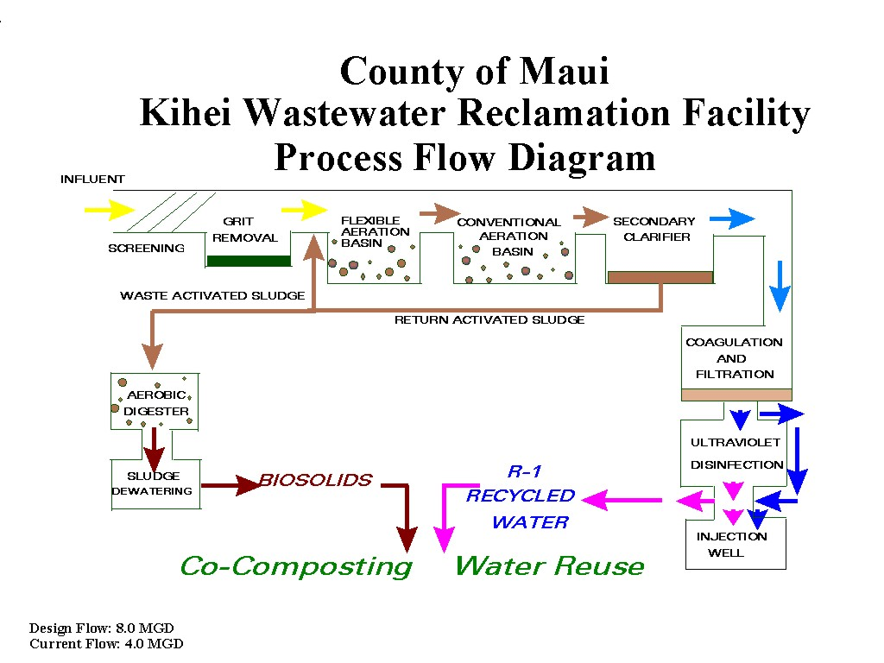

Figure 2: Kihei WWRF Process Flow Diagram

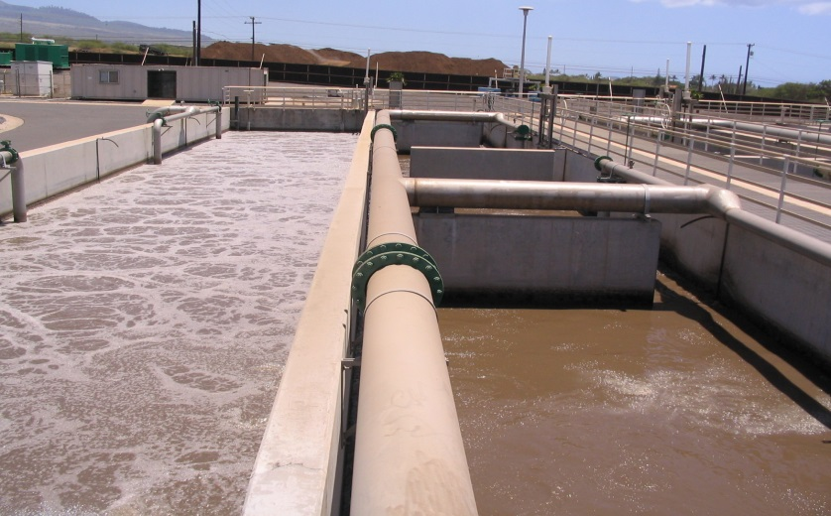

The right side of this photo shows an anoxic zone in a Flexible Aeration Basin at the Kihei WWRF. The lack of an adequate supply of free dissolved oxygen promotes denitrification of nitrate to nitrogen gas by heterotrophic bacteria.

Figure 3: Kihei WWRF Flexible Aeration Basin

### 2.11 Options to Reduce the Impact of the Kihei WWRF Injection Wells on the Environment and Public Health

#### 2.11A Improve the Quality of the Effluent Injected

One of the first thoughts that come to mind when considering how to reduce the use of injection wells for effluent disposal is to simply increase the use of the recycled water that the WWRF generates. The County of Maui’s Wastewater Reclamation Division (WWRD) has made great strides in this area over the last 20 years. Maui is the only county in Hawaii to establish a provision in the Maui County Code that requires commercial properties to utilize recycled water for landscape irrigation if it is available. Chapter 20.30 Use of Reclaimed Water2 was established in 1996 and it has been very effective in not only reducing the use of injection wells for effluent disposal but also in savings of vast quantities of potable water.

The WWRD is slowly but surely expanding its distribution system in South Maui so that more recycled water can be used. However, there are limitations to water reuse potential that must be considered. First of all, the volume of recycled water utilized by end users is dependent on seasonal climatic conditions. Irrigation demands are very high during the months of May through October but dramatically decline during the cooler, wetter months of November through April. A case in point is the Maui Nui Golf Club, the largest volumetric user of recycled water from the Kihei WWRF. During the warmer summer months, their daily irrigation demand is close to 1.0 MGD. However, during the winter months, their daily irrigation demand drops as low as 0.3 MGD. This seasonal variation in irrigation requirements results in far more effluent being disposed of into the Kihei WWRF’s injection wells during the winter months than in the summer months.

Another limitation is that the cost to expand the recycled water distribution system is extremely high. Constructing water distribution systems costs millions of dollars and since the WWRD’s main responsibility is to collect and treat wastewater; funding for recycled water distribution system expansions is not its top priority.

The injection wells cannot be simply turned off. Not only are they currently used to dispose of the effluent that is not needed for water reuse projects, they serve as the required back up disposal mechanism as required by the HDOH WWB’s HAR 11-62 Regulations. Therefore, it makes sense to improve the quality of the effluent that is disposed of into the injection wells. This can be accomplished in two ways.

2.11A-1 Option 1: Disinfect all of the effluent that the Kihei WWRF produces to R-1 recycled water standards using ultra violet (UV) disinfection

Currently, only the effluent that is sent to the recycled water users is disinfected with UV. The Kihei WWRF has ample UV disinfection capacity to also disinfect the effluent that is directed to its injection wells. A piping connection from the facility’s UV disinfection channel to the injection well system is required and would need to be constructed. The WWRD will also need to budget accordingly as disinfecting all of the Kihei WWRF’s effluent will result in additional costs due to the required additional electricity, UV equipment parts and labor. Disinfecting the effluent that is injected will address the concern that the Kihei WWRF’s injection wells are contaminating the ground water and ultimately the near shore coastal waters with pathogenic organisms.

2.11A-2 Option 2: Improve the nutrient removal capability at the Kihei WWRF

As stated previously, the Kihei WWRF is already utilizing BNR to reduce nutrients (primarily nitrogen) in its effluent. Total nitrogen is reduced to between 8 and 12 mg/L. Reducing the nutrient level in the Kihei WWRF effluent will address the concern that injection wells are contributing nutrients that leach into the coastal waters via groundwater seeps. It will also address the concern that the recycled water that is used for landscape irrigation at locations near the coastline is leaching past vegetation root zones and contributing nutrients to coastal waters. There are two methods than could be considered to improve nutrient removal at the Kihei WWRF.

2.11A-2a Option 2A: Utilize the Bardenpho Process

The Bardenpho Process is effective at removing nitrogen and phosphorous by alternating anaerobic, anoxic and aerobic zones in the activated sludge basins. The Lahaina WWRF has successfully utilized a similar concept and has been able to reduce effluent total nitrogen to as low as 5 mg/L. This concept will require some study by the WWRD to determine if it can be configured at the Kihei WWRF and if it can, it should be able to be set up fairly quickly.

2.11A-2b Option 2B: Utilize Enhanced Nutrient Removal (ENR) Technology

Enhanced Nutrient Removal (ENR) has been successfully utilized at WWRFs in other parts of the United States where effluent is discharged to sensitive receiving waters. The Chesapeake Bay Restoration Program was created to improve the water quality of Chesapeake Bay. Part of this program required WWRFs that discharge to the Bay to improve their nutrient removal capacity so that effluent total nitrogen does not exceed 3 mg/L and total phosphorous does not exceed 0.3 mg/L.3 ENR is accomplished by adding methanol or some other carbon source to either anoxic zones in activated sludge basins or to deep bed effluent filters. The additional carbon drives denitrification further so that lower total nitrogen and phosphorous levels can be achieved. The Kihei WWRF is not equipped with deep fed effluent filters. Thus, ENR could be accomplished by adding methanol to an anoxic zone in a Bardenpho Process configuration. This concept will need to be evaluated by a consulting engineering firm that specializes in wastewater treatment design to determine if it is feasible at the Kihei WWRF. Figure 4 shows the Bardenpho Process with supplemental carbon addition.

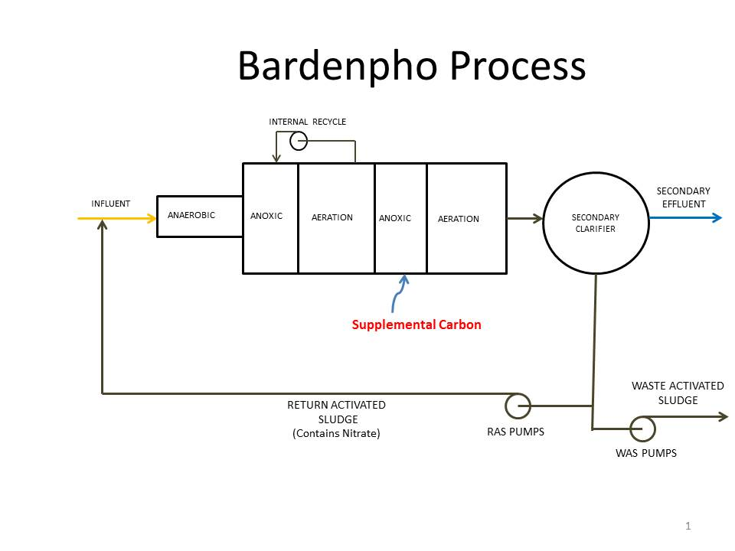

Figure 4: The Bardenpho Process with Supplemental Carbon Addition

#### 2.11B Increase the Use of R-1 Recycled Water

As stated earlier, the WWRD has established a water reuse program and there are numerous commercial properties that utilize R-1 recycled water for landscape irrigation in the South Maui area. The WWRD’s water reuse program is funded primarily through sewer user fees (75%) and recycled water fees (25%). Increasing the use of recycled water will reduce the use of injection wells for effluent disposal as well as help save potable water. Below are some ways to increase the use of recycled water.

2.11B-1 Broaden the Funding Base for the WWRD’s Water Reuse Program

The County of Maui established a Wastewater Community Working Group4 in 2010 during the administration of Mayor Charmaine Tavares to determine ways to increase the use of recycled water and reduce the use of injection wells, septic tanks and cesspools near coastal locations. Broadening the funding base for the WWRD’s water reuse program was determined to be a top priority. The group decided that additional funding for recycled water system expansions could be obtained from the following sources:

* 1. **The County of Maui Department of Water Supply (DWS):** The WWRD’s water reuse program directly offsets the use of potable water that is used for landscape irrigation. The Water Department benefits greatly from the WWRD’s water reuse program. Currently, over 600 million gallons per year of potable water is saved.
  2. **Property Taxes:** An “environmental” or “flush” fee could be created as part of Maui County’s property tax system. This method would spread the cost of paying for recycled water production and distribution infrastructure over a wide base. Property taxes are generally low in Maui thus the financial impact to residents and the commercial sector would be minimal.
  3. **The Visitor Industry:** Tourism is Maui’s largest industry and visitors who come to Maui generate large volumes of wastewater on a daily basis. An environmental fee could be included as part of their hotel bill to help pay for recycled water system expansions.
  4. **Developers:** As a condition of development, developers could be assessed a specified dollar amount per gallon of projected wastewater flow from their respective developments. A similar approach was utilized in West Maui to help pay for recycled water system improvements in that area.

Unfortunately, with the change of mayoral administrations, the recommendations of the Wastewater Community Working Group were not implemented. The recommendations however could be implemented in the future under future mayoral administrations and with the support of the County Council.

2.11B-2 Utilize Recycled Water in the Wailea Area of South Maui

Landscapes at Wailea’s hotels and condominiums use vast quantities of potable water for irrigation. There are also three golf courses that utilize brackish groundwater for irrigation. Displacing potable water used for landscape irrigation with R-1 recycled water would go a long way in preserving Maui’s limited fresh water supplies. Golf courses use large volumes of water on a daily basis. Using recycled water for irrigation at even one of Wailea’s golf courses would dramatically reduce the use of injection wells for effluent disposal. Two concepts that could be considered would be to expand the Kihei WWRF’s recycled water distribution system to the Wailea area and construct a wastewater “scalping” facility in Wailea for the purpose of treating and recycling the wastewater closer to its point of origin. These concepts are discussed below.

2.11B-2a Construct an Expansion of the Kihei WWRF’s Recycled Water Distribution System to the Wailea Area

The WWRD completed its *South Maui R-1 Recycled Water Verification Study5* in 2009. At that time, it was estimated that expanding the distribution system to Wailea would cost approximately $21 million. Several resorts and the Wailea Blue Golf Course were listed as potential users of the R-1 recycled water. The peak R-1 recycled water demand was estimated at 2.2 MGD with over 1.0 MGD of potable water savings being realized. An advantage to this concept is that during the winter months when injection well use typically increases at the Kihei WWRF due to declining irrigation demands, more recycled water could be delivered to the Wailea Blue Golf Course. During the summer months, when irrigation demands increase at existing water reuse projects, the Wailea Blue Golf Course could switch back to its brackish groundwater as its primary irrigation source. This scenario would help alleviate the challenge of the injection wells being relied upon more heavily during the cooler, winter season.

2.11B-2b Construct a “Scalping” Wastewater Reclamation Facility in the Wailea Area

A regional wastewater facility could be constructed in a location that would intercept the wastewater from the Wailea area. Instead of the wastewater being conveyed to the Kihei WWRF, it could be treated to R-1 recycled water standards and used for landscape and/or golf course irrigation. By decentralizing wastewater treatment in the South Maui area, the use of recycled water can be significantly increased. The WWRD is planning to have a study performed by a consulting engineering firm to evaluate locations in Maui County where scalping facilities could be situated. A determining factor in deciding if to construct such a facility would be how the costs (land, facility construction, operation and maintenance) compare to extending the WWRD’s recycled water distribution to the Wailea area. The cost to develop a regional recycled water distribution system in the Wailea area also would need to be included in this analysis.

#### 2.11C Recommendations

The County of Maui is already involved in litigation due the use of injection wells at its Lahaina WWRF. To proactively avoid lawsuits for the continued reliance on injection wells at the Kihei WWRF, it is recommended that Option 1 in Section 2.11A-1; disinfecting the effluent that is disposed of into the Kihei WWRF’s injection wells to R-1 recycled water standards and Option 2A in Section 2.11A-2a; utilizing the Bardenpho process; should be implemented. Option 2B in Section 2.11A-2b, utilizing ENR should be considered if the attempting to use the Bardenpho process at the Kihei WWRF is unsuccessful in reducing total nitrogen concentrations to at least 5 mg/L in the Kihei WWRF effluent.

Furthermore, the County of Maui needs to place a higher priority on its water reuse program by broadening the funding base for the WWRD’s water reuse program. Public testimony should be provided to the County Council urging them to approve this concept. The WWRD needs to complete a study on decentralized wastewater treatment and consider constructing a scalping WWRF in the Wailea area if the cost to do so is less expensive than expanding its recycled water distribution to this location.

## 2.2 Maalaea

The Maalaea area of South Maui is outside the service zone of the County of Maui’s Kihei WWRF (see Figure 5). There are ten condominium complexes, each with its own small wastewater treatment plant and shallow injection wells. Wastewater from the Maalaea Harbor Mall and the Maui Ocean Center is treated by a small wastewater facility. This facility also has injection wells. Finally, there is a small package facility that treats wastewater from boats that dock in Maalaea Harbor. There are a total of 23 injection wells used for the disposal of treated wastewater in this area.

Many of the condominiums were built in the late 1970’s and early 1980’s and have been treating their own wastewater and discharging the treated effluent into injection wells since that time. The injection wells utilized by the condominiums are very shallow being only 40 to 60 feet in depth. It is estimated that approximately 200,000 gallons per day (GPD) of wastewater is treated at the condominiums’ wastewater treatment plants and disposed of into the injection wells.6 The health of coral reefs has declined in Maalaea Bay and the injection wells have been suspected of contributing to this decline. Invasive macro algal blooms have also been a problem in Maalaea. The County of Maui’s WWRD hired Marine Research Consultants, Inc. in 2011 to conduct a study to identify point and non-point pollutant and nutrient sources that may have led to drastic declines in coral health and complexity of the benthic community and subsequently promoted excessive algal growth in Maalaea Bay.7 The study concluded that while injection wells are likely causing some enhanced algal growth in the inner bay, they do not appear to be the cause of the observed decline in coral communities. Rather, sediment was determined to be the main factor affecting the coral reef health. The study recommended that any actions taken to improve the health of coral reefs should center on reduction of sediment stresses.

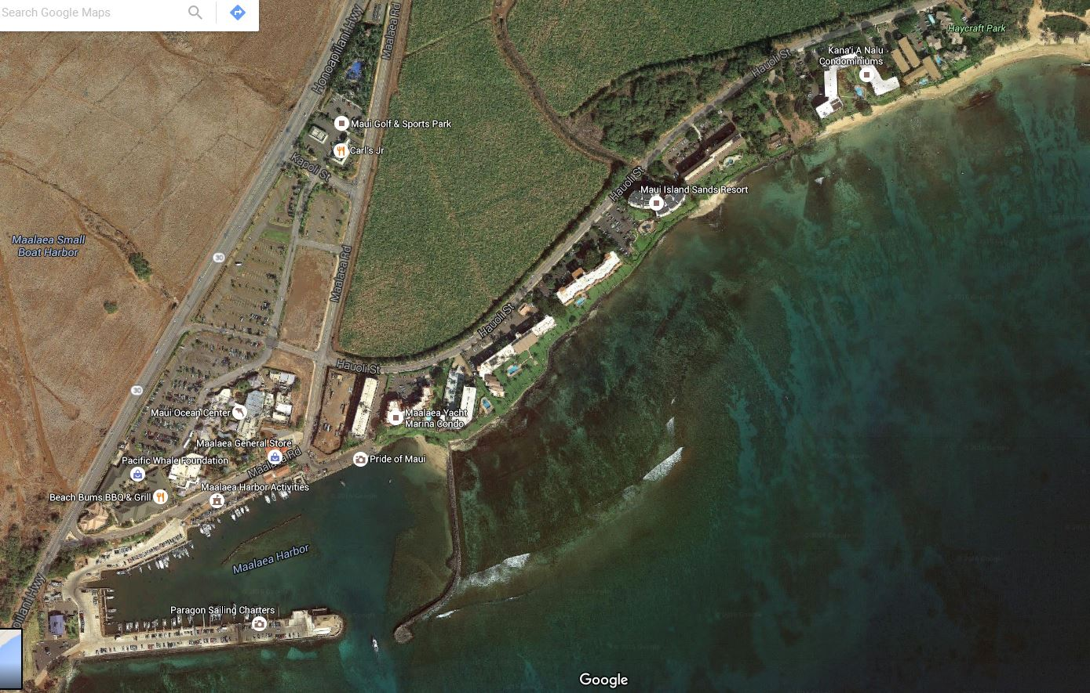

Figure 5: The Maalaea Area’s Existing Commercial and Multi-Family Developments

### 2.21 Options to Improve Wastewater Management in the Maalaea Area

Many of the wastewater treatment facilities serving each condominium complexes are aging and outdated. These facilities all utilize the activated sludge process to perform secondary treatment but are not designed to remove nutrients through BNR. These facilities could be upgraded to more modern systems that can perform BNR or a regional wastewater reclamation facility that serves the entire Maalaea area could be built. A discussion on each option follows.

#### 2.21A Option 1: Upgrade Existing Wastewater Facilities

The existing wastewater facilities that service the Maalaea condominiums could be upgraded with activated sludge systems that perform BNR. Effluent filtration could be installed at each facility to polish the final effluents by removing additional suspended solids. Disinfection could be added to allow the recycled water from the facilities to be used for for landscape irrigation. While producing R-1 recycled water is possible, the daily bacteriological monitoring required by the HDOH WWB recycled water guidelines can be cost prohibitive. R-2 recycled water only requires weekly bacteriological monitoring however the R-2 water would need to be applied via subsurface irrigation to avoid public contact and meet the requirements of the HDOH WWB’s recycled water guidelines. Should water reuse be implemented, the condominiums could significantly reduce the use of their respective injection wells. A permit for implementing the use of recycled water must be obtained by each condominium from the HDOH WWB. Option 1 would be the most economical and feasible approach to improving the quality of the effluent and reducing the use of injection wells in the Maalaea area. However, any improvements of the condominiums WWRFs would require approval from their respective boards of directors.

#### 2.21B Option 2: Construct a Regional Facility That Serves the Maalaea Area

A regional facility that treats wastewater from the Maalaea area could be constructed. Since A&B Properties will no longer be growing sugar cane in the area, a parcel of land could be purchased where such a facility could be located. Each condominium and potentially the Maalaea Harbor Mall and other commercial establishments in the area would need to install a wastewater pump station to convey their respective wastewater to the new wastewater reclamation facility. The facility should be designed to produce R-1 recycled water that could be used for either landscape irrigation or for the irrigation of other crops that are grown on adjacent agricultural land. Back up effluent disposal is required. Rather than drill new injection wells, it is recommended that a Soil Aquifer Treatment (SAT) system be utilized to dispose of excess recycled water and for recycled water that does not meet R-1 recycled water standards. A SAT system consists of a series of shallow basins that are used intermittently to allow effluent to percolate through the soil. SAT basins are the preferred alternative disposal means as they further polish the water through slow percolation and reduce the possibility of contaminating the underlying aquifer when compared to injection wells. SAT utilizes physical, chemical and biological properties of the soil to improve the water quality of the wastewater effluent.

This option would be several orders of magnitude more expensive that Option 1 and there are significant challenges to this concept. The first major challenge is that the regional facility would need to be located outside area’s flood zone which extends approximately 900 feet in from the shoreline. This means that the facility very likely would have to be located mauka of the Honoapiilani Highway. Crossing four lanes of highway drastically increases the cost of this option. Another significant challenge is to gain consensus to fund this option from all of the ten condominiums’ board of directors and other property owners in the area.

#### 2.21C Recommendations

Option 1 is the most feasible and cost effective option to improve the quality of the effluents and reduce the use of injection wells at the Maalaea condominiums. It also has the added benefit of contributing to sustainability by making use of the recycled water for landscape irrigation. Nutrients that do remain in the effluents can be used by the irrigated vegetation thus allowing the condominiums to reduce the use of chemical fertilizers on their properties.

A challenge to implementing Option 1 at all ten condominiums in convincing their respective boards of directors to approve funding to pay for improvements at their WWRFs as any improvements will result in an increase to monthly maintenance fees paid by the owners. At least one of the condominiums; the Banyans, is moving forward with an upgrade to their WWRF. However, there potentially could be some resistance to by the respective boards of directors at other condominiums to approve funding upgrades to their WWRFs due to the associated costs. The County of Maui’s Planning Department could mandate that each condominium upgrade their WWRF with BNR and implement recycled water use through the Special Management Area (SMA) process. An SMA permit is typically required for any improvement proposed in the Maalaea area due to the condominiums’ proximity to the ocean. Improving nutrient removal capabilities and implementing water reuse at each condominium could be made a condition of SMA permit approval.

## 2.3 Maui Meadows

Maui Meadows has over 600 rural and agricultural zoned lots and is located mauka of the Piilani Highway above the north section of the Wailea region of South Maui (see Figure 6). This subdivision lies outside of the Kihei WWRF service area therefore each residence has its own IWS. Most residences utilize either a cesspool or a septic system. A cesspool is essentially a deep hole where untreated wastewater percolates down through the soil. Pathogens, nutrients and other pollutants can reach the groundwater and eventually the coastal waters through groundwater seeps. A septic system consists of a settling tank that allows solids to settle with the clarified effluent overflowing the tank and being disposed of through a drain field. A drain field consists of buried perforated pipes that allow the effluent to be dispersed over a wide area, typically in the yard of a residential lot. Solids must be pumped from septic tanks periodically to prevent drain field clogging. Figure 7 shows a cesspool. Figures 8 shows a septic tank and Figure 9 shows a complete septic system.

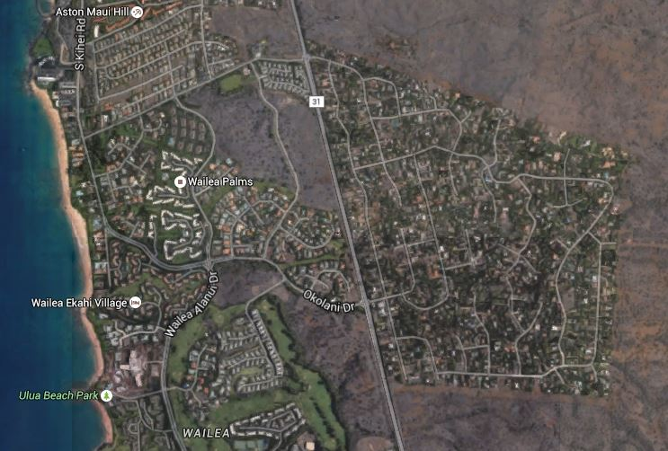

Maui Meadows

Figure 6: Maui Meadows Subdivision

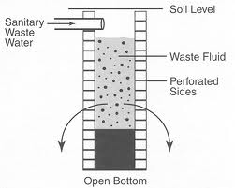

A cesspool allows untreated wastewater to leach into groundwater. Pathogens, nutrients and other pollutants can contaminate groundwater and ultimately reach coastal waters through groundwater seeps.

Figure 7: Cesspool

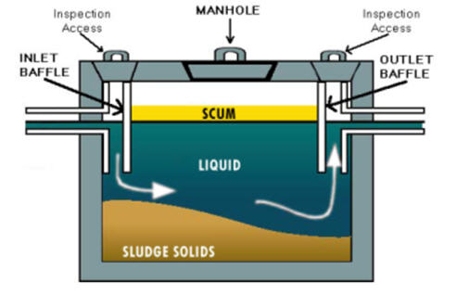

A septic tank allows scum to float to the top of the tank and solids to settle to the bottom of the tank. Septic tanks should be pumped every 3 to 5 years to remove the scum and sludge solids.

Figure 8: Septic Tank

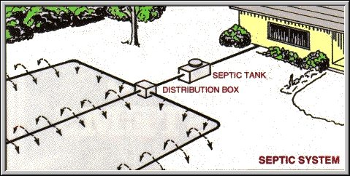

A complete septic system showing the septic tank and drain field.

Figure 9: Septic System

A septic system reduces the biochemical oxygen demand (BOD) and the total suspended solids (TSS) of the raw wastewater by approximately 30 – 40%. Effluents from a septic system still contains dissolved solids and suspended solids that in theory are assimilated by soil bacteria in the drain field. Drain fields can become clogged if accumulated solids from septic tanks are not pumped on a regular basis; typically at least every three to five years. An approach that is now being utilized to reduce pollution of sensitive receiving waters is to upgrade cesspools and septic systems to Aerated Treatment Units (ATUs). An ATU provides secondary treatment by aerating the wastewater to convert dissolved and suspended solids to settleable solids. The settleable solids will settle in a clarifier and leave a relatively clear supernatant behind. ATUs have been shown to rejuvenate clogged septic system drain fields since the effluent quality is superior to that of septic systems. ATUs however require electricity and are more expensive to operate and maintain than a septic system. Most ATUs are sold with a two year service contract. Manufacturers and regulators recommend that such a contract be extended for the life of the unit.8 Figure 10 shows a typical ATU.

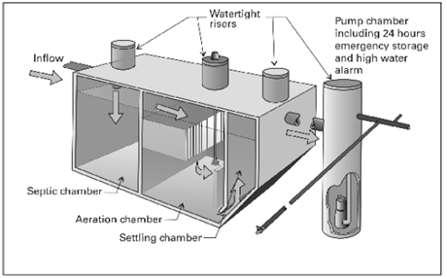

Figure 10: Aerated Treatment Unit

### 2.31 Options to Improve Wastewater Management in Maui Meadows

There are three conceptual options to consider for improving wastewater management in Maui Meadows.

1. Upgrade all cesspools to either septic systems or ATUs
2. Connect the subdivision to the County of Maui’s sewer system
3. Construct a regional wastewater reclamation facility

Below is a discussion of each conceptual option.

#### 2.31A Option 1: Upgrade All Cesspools to Either Septic Systems or ATUs

Upgrading the cesspools in Maui Meadows to septic systems or ATUs is more than likely the most feasible option to improve wastewater management in this area. The State Legislature has established a program under “Act 120” that provides a temporary income tax credit for the cost of upgrading or converting a qualified cesspool to a septic tank system or an aerobic treatment unit system, or connecting to a sewer system in certain designated areas of Hawaii. A taxpayer may apply for a tax credit of up to $10,000 for each qualified cesspool.9 Unfortunately, Maui Meadows is not in a location that qualifies for Act 120 since the area is not located within 200 feet of a shoreline, perennial stream, wetland, or within a source water assessment program area (two year time of travel from a cesspool to a public drinking water source).

Thus, the costs of upgrades of cesspools within Maui Meadows must be paid for by the property owners. This fact will slow the pace of converting cesspools to septic systems or ATUs in Maui Meadows.

#### 2.31B Option 2: Connect the Subdivision to the County of Maui’s Sewer System

Connecting Maui Meadows to the County WWRD sewer system is not as simple as running a sewer pipe from the subdivision down to the main sewer system located along South Kihei Road. A complete wastewater collection system would need to be installed within Maui Meadows. The collection system would include sewer laterals, main lines, trunk lines and manholes. Since Maui Meadows is not flat, any homes that lie below the main sewer line in the street may need to pump their own wastewater to the main line. This fact would incur additional costs borne by the homeowners for the operation and maintenance of their respective pumping stations.

A main trunk line would then need to be installed to connect Maui Meadows to the WWRD collection system. Before doing so, a hydraulic analysis of the WWRD’s existing wastewater collection system would need to be conducted to determine if there is sufficient capacity in the system to handle the increased wastewater flow. Wastewater flow from Maui Meadows is not metered but it can be estimated. Assuming that one half of the 600 plus lots has two dwellings; it can be estimated that there are approximately 900 single family homes in Maui Meadows. Using the industry standard of 350 gallons of wastewater per day per single family home, wastewater flow from Maui Meadows can be estimated at approximately 315,000 GPD or 0.315 MGD.

The WWRD has included installing a sewer system in the Maui Meadows subdivision and connecting it to their existing collection system. Funding for a preliminary engineering report and design are tentatively scheduled for fiscal year 2021. If constructed, the estimated cost is approximately $25 million. The WWRD however is considering dropping this capital improvement project because they have not received support from the County Council to construct wastewater collection systems in existing developments. The cost for the homeowners to connect service laterals to the system has been determined to be too high by the County Council.10

#### 2.31C Option 3: Construct a Regional Facility that Serves Maui Meadows.

Constructing a new WWRF roughly costs about $35 to $40 per gallon of capacity. At $35 per gallon, and assuming that the facility would be designed for 0.315 MGD, the estimated total cost would be over $11 million. The cost of the wastewater collection system, land for the WWRF, a SAT system and a recycled water distribution system would need to be added to this cost of the WWRF. It is doubtful that property owners in Maui Meadows would elect to construct their own WWRF due to the extreme costs associated with this option.

#### 2.31D Recommendations

While Option 2 is likely the best overall solution to improving wastewater management in Maui Meadows; it does not appear that it is a high priority with the County of Maui at this time. Therefore, Option 1, upgrading all cesspools to either septic systems or ATUs described in Section 2.31C is the most feasible option to improve wastewater management in Maui Meadows. Ways to accelerate these upgrades could include a property tax credit granted to property owners who upgrade their cesspools. Another course of action is to lobby the State Legislature to expand Act 120 to other non-sewered areas in Hawaii that may be suspected of contributing to groundwater and coastal water quality pollution. Research however may need to be conducted to prove that wastewater from the cesspools in Maui Meadows is actually reaching the coastal waters and causing water quality issues. One action that has already been implemented by the HDOH WWB is to require that cesspools be upgraded to either septic systems or ATUs when property owners apply for building permits to construct improvements on their properties. Maui Meadows homeowners can also be educated about the benefits of upgrading their cesspools to septic systems or ATUs.

## 2.4 Makena

The Makena region is south of Wailea (see Figure 11). Several new homes with their own individual wastewater systems are located in close proximity to the ocean. While some cesspools may be present at older homes in the area, most of the homes are believed to have septic systems. New cesspools are severely restricted in Hawaii and are prohibited by the HDOH WWB in designated critical wastewater disposal areas on all islands. The Makena region is considered a critical wastewater disposal area by the HDOH WWB.

The Makena WWRF serves the former Maui Beach and Golf Resort. Its capacity is 0.75 MGD however it is only receiving a daily flow of approximately 0.1 MGD at this time. All of the R-1 recycled water produced by the Makena WWRF is blended with brackish ground water and used for irrigation of the resort’s golf course. The Makena WWRF does not have injection wells. There are also plans for the wastewater from the future Honuaula residential project to be sent to the Makena WWRF. This development has been approved by the Maui County Council and will proceed once the local economy improves. Up to 0.5 MGD of wastewater is expected to be produced once the project is fully completed. An equal volume of R-1 water will be pumped back to the Honoaula development, blended with brackish water and used to irrigate a golf course and common areas.11

### 2.41 Options to Improve Wastewater Management in Makena

The cesspools and failing septic systems at single family homes located in close proximity to the coastline in Makena are the main concern pertaining to wastewater management in this region. There are three conceptual options that could be considered to address this concern.

1. Upgrade all cesspools and failing septic systems to ATUs.
2. Connect the single family homes to the Makena WWRF.
3. Extend the WWRD wastewater collection system to Makena.

Below is a discussion of each option.

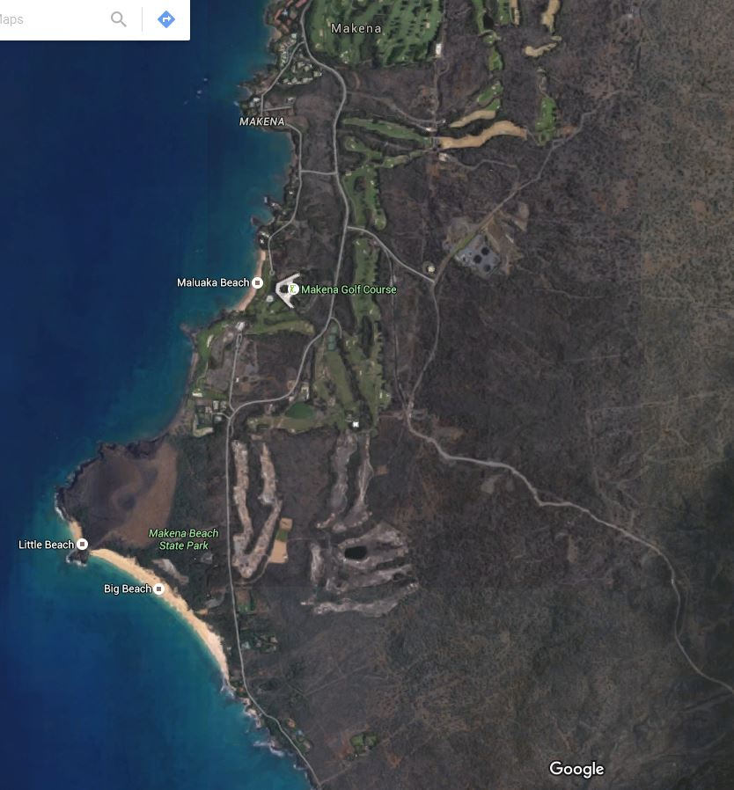

**Makena WWRF**

Figure 11: Makena

#### 2.41A Option 1: Upgrade All Cesspools and Failing Septic Systems to ATUs

Act 120, previously described in Section 2.31A, does apply to Makena because most of the single family homes are within 200 feet of the shoreline. Thus, any single family home that is still disposing of its wastewater to a cesspool would qualify for the $10,000 tax credit. Septic systems that are failing due to clogged leach fields should also be upgraded to ATUs. A property with a failing septic system most likely will not qualify for Act 120 and will have to pay for upgrading to an ATU and a service contract for its operation and maintenance.

#### 2.41B Option 2: Connect Single Family Homes to the Makena WWRF

The Makena WWRF is well below its design capacity of 0.75 MGD and there is currently enough capacity to treat the wastewater from single family homes in the region. However, there would need to be a wastewater collection system, a number of pump stations and a sewer force main to the Makena WWRF constructed. The cost of such a project would most likely far exceed the cost of upgrading the existing individual wastewater systems at the single family homes in the region. Capacity at the Makena WWRF is also being reserved for future development within the resort area as well as for the proposed Honualua development.

#### 2.41C Option 3: Extend the WWRD Collection System to Makena

The WWRD has no plans at this time to extend its wastewater collection system to the Makena region due to the associated costs of such a project and the relatively low density of single family homes. An important point to consider is that due to the relatively low density of single family homes in Makena, the construction of a wastewater collection system in this area could result in significant odor problems due to excessively long detention time of the wastewater in the collection system. Thus, this option should not be seriously considered at this time.

#### 2.41D Recommendations

The most feasible option to improve wastewater management in Makena is Option 1; upgrade all the cesspools and failing septic systems to ATUs. While Act 120 would provide a tax credit to those homeowners upgrading cesspools, it is unlikely that a tax credit would be available for those who want to upgrade a failing septic system. The State Legislature could be lobbied to extend Act 120 to upgrade failing septic systems to ATUs.

It is recommended that Makena home owners be educated about the benefits associated with upgrading their systems to ATUs. Benefits would include improved coastal water quality, healthier coral reefs and extending the life of drain fields. An educational pamphlet could be developed by the MNMRC to educate the home owners. Educational presentations by the MNMRC could also be developed to further this initiative.

# 3. Summary of Recommendations

Table 3-1 summarizes the options recommended in Section 2.

**Table 3-1: Recommended Options to Improve Wastewater Management in South Maui**

|  |  |  |
| --- | --- | --- |
| **Region/Location/**  **Responsible Party** | **Priority** | **Options Recommended** |
| Kihei WWRF  County of Maui  WWRD | 1 | * Disinfect effluent that is disposed into injection wells with UV * Improve BNR with Bardenpho Process to reduce total nitrogen to 5 mg/L * Evaluate ENR feasibility with goal of reducing total nitrogen to 3 mg/L or less |
| Kihei WWRF  County of Maui  WWRD | 2 | * Elevate priority of water reuse program * Compare cost of extending recycled water distribution system to Wailea with cost of a scalping facility in the Wailea area. Construct most economical option |
| Maalaea  Condominiums | 3 | * Upgrade all WWRFs at condominiums to activated sludge with BNR * Implement water reuse with R-2 recycled water via subsurface irrigation systems |
| Maui Meadows | 4 | * Upgrade cesspools to septic systems or ATUs |
| Makena | 5 | * Upgrade cesspools and failing septic systems to ATUs |

The MNMRC can play an important role in gaining support for wastewater management improvements in South Maui. Suggested activities that the MNMRC can undertake include:

* Provide presentations and public testimony to the Administration and County Council to:
  + Improve the quality of effluent that is disposed into the Kihei WWRF injection wells
  + Place a higher priority on the WWRD’s water reuse program by broadening its funding base
  + Include conditions in the Maalaea condominiums’ SMA permits that require that that their respective WWRFs are upgraded to include BNR and that reuse of recycled water be implemented
  + Request a property tax credit for homeowners who upgrade their cesspools to septic systems or ATUs (in areas where Act 120 does not apply)
* Promote research to determine if wastewater from Maui Meadows is reaching the ocean and contributing to coastal water quality degradation
* Request that State Legislature extend Act 120 to other non-sewered areas where cesspools and failing septic systems are suspected of contributing to coastal water quality degradation
* Educate the Makena community about Act 120
* Promote conversion of cesspools and failing septic systems in Makena/Maui Meadows with educational pamphlets and presentations

# 4. References

1. Miller-Pierce, M.R. & N.J. Rhodes. 2016. *The influence of wastewater discharge on water quality in Hawai`i: A comparative study for Lahaina and Kihei, Maui*. Marine Pollution Bulleting, MBP-07399, pp 1-9.
2. Maui County Code. Title 20 Environmental Protection, *Chapter 20.30 Use of Reclaimed Water.* <https://www.municode.com/library/hi/county_of_maui/codes/code_of_ordinances?nodeId=TIT20ENPR_CH20.30USREWA>
3. State of Maryland. The Department of the Environment. Senate Bill 320 (Bay Restoration Fund). http://www.mde.state.md.us/PROGRAMS/WATER/BAYRESTORATIONFUND/Pages/index.aspx
4. Wastewater Community Working Group Final Report. 2010. *Maui’s wastewater management future: charting a course to increased water recycling and reduced reliance on injection wells. Report and recommendations of the Maui wastewater community working group.* <http://www.mauicounty.gov/DocumentCenter/Home/View/12037>
5. County of Maui, Wastewater Reclamation Division. 2009. *South Maui R-1 Recycled Water Verification Study,* pp 1-15. <http://www.mauicounty.gov/DocumentCenter/Home/View/12704>
6. Doust, Pam. Maalaea Community Association. Interview conducted on July 15, 2016.

Dollar, S., M. Atkinson, E. Hochberg. T. Nance. 2011. *An evaluation of casual factors affecting coral reef community structure in Ma`alaea bay, Maui, Hawaii,* pp 1-89. <http://www.mauicounty.gov/DocumentCenter/View/83262>

Pipeline. Small Community Wastewater Issue Explained to the Public. 2005. *Aerated treatment units: An alternative to septic systems.* Volume 16, No. 3, pp 1-7. <http://www.nesc.wvu.edu/pdf/WW/publications/pipline/PL_SU05.pdf>

State of Hawaii, Department of Health Wastewater Branch website. <http://health.hawaii.gov/wastewater/home/taxcredit/>

Rollins, Scott. County of Maui, WWRD Planning Section. Email communication on July 18, 2016.

Department of Land and Natural Resources, Commission on Water Resource Management. 2013. *2013 Update of the Hawaii water reuse survey and report.* Pg. 3-35. <http://files.hawaii.gov/dlnr/cwrm/planning/hwrsr2013.pdf>